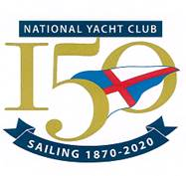
Nominations for Honorary Membership 2021

Name | Proposer | Seconder
Cathy MacAleavey | Martin McCarthy | Rosemary Cadogan

NYC first lady Olympian, long term NYC Junior Organizer and Services to World Sailing

Name | Proposer | Seconder
Stephen Tudor | Peter Ryan | Martin McCarthy

Former Commodore of Pwllheli Sailing Club and stalwart in enabling the growth of ISORA

