SPEAKER SUPPER
March 19th 2015

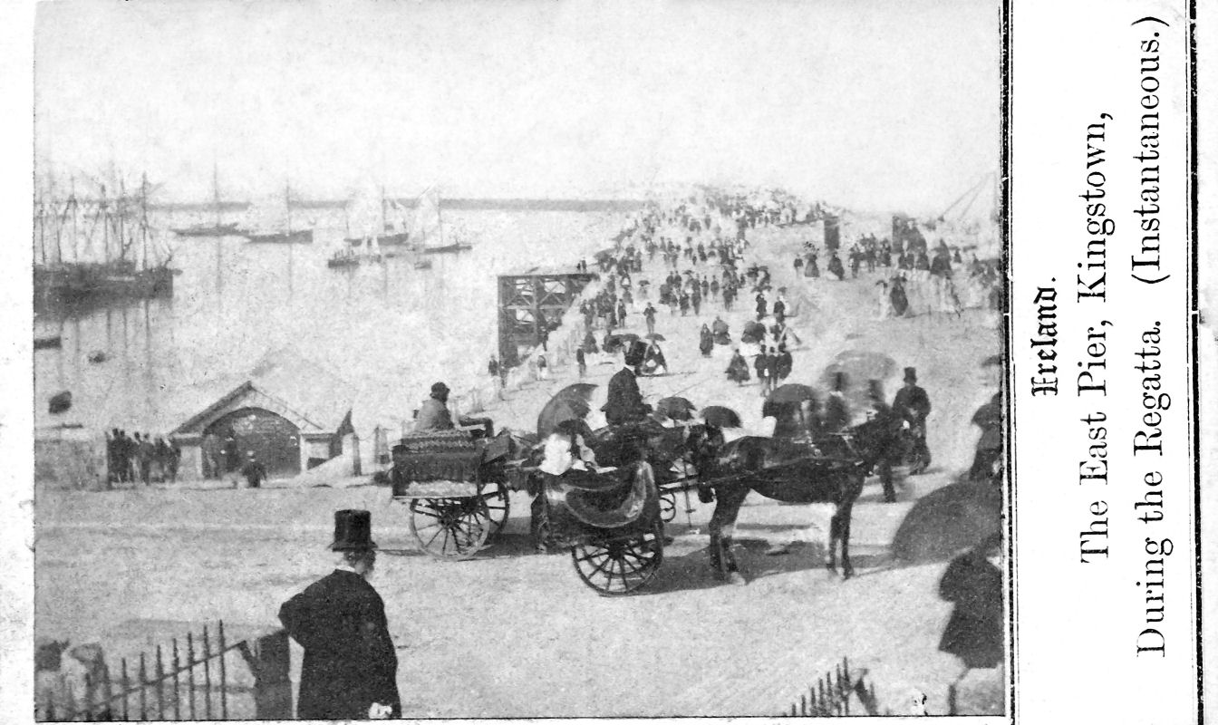

Irish emigrants in the US wanted photos of their homeland in the 1860s, and US-based publishers rose to meet the demand. These are the oldest surviving photos of Monkstown, Killiney, Dalkey, Bray and Kingstown, and have been assembled mainly from US sources by a Wexford-based collector. These pictures will be published in a book by Tom Conlon later in 2015

Tom Conlon from the Dun Laoghaire Borough Historical Society will be speaking at this month’s Speaker Supper showcasing photographs of Monkstown, Killiney, Dalkey, Bray and Kingstown from his upcoming book.

