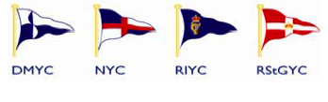
Dun Laoghaire Access Sailing Programme 2011

For Children aged 8 to 17 with physical and sensorial disabilities

National Yacht Club - Royal St George Yacht Club –
Royal Irish Yacht Club - Dun Laoghaire Motor Yacht Club

The above clubs have joined forces again to run this programme throughout the summer 2011

Programme
1. An Introductory Day - Sunday morning 19th June 2011 at the Royal Irish Yacht Club
2. Sunday morning sailing - will commence Sunday 26th June and continue each Sunday until 21st August - run by the
Royal St George Yacht Club and D/L Motor Yacht Club
3. Two 4-day sailing courses -
Tuesday 21st - Friday 24th June at National Yacht Club
Tuesday 2nd - Friday 5th August at Royal Irish Yacht Club

No sailing experience is necessary

To register interest or for more detail please contact:
Ian French 087 2456834 email: ianafrench@eircom.net
Katy McGuinness 087 2632220
email: katymcguinness@gmail.com
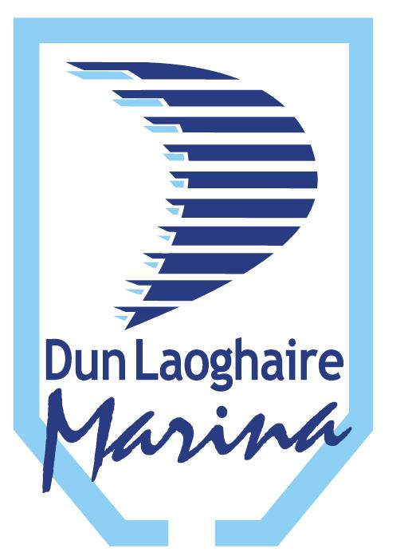

Supported by:
Dun Dun Laoghaire Marina – Dublin Port Company

